CS 6327 Video Analytics Assignment 1
Instructor: Dr. B. Prabhakaran TA: Kanchan Bahirat
Due - Jan 27th, 2016
Only submission on eLearning is accepted.
Description:
Given an image with various fruits (Fig. 1), please:
- Generate three different images by adjusting the brightness of each pixel in the original image by +10, +50, +100.
- Convert each image from RGB to HSV color space.
- Find the “oranges” in each image using both of the following methods and mark the orange area as white in the dark background. Methods to be used:
- Object detection based on color in RGB domain
- Object detection based on color in HSV domain
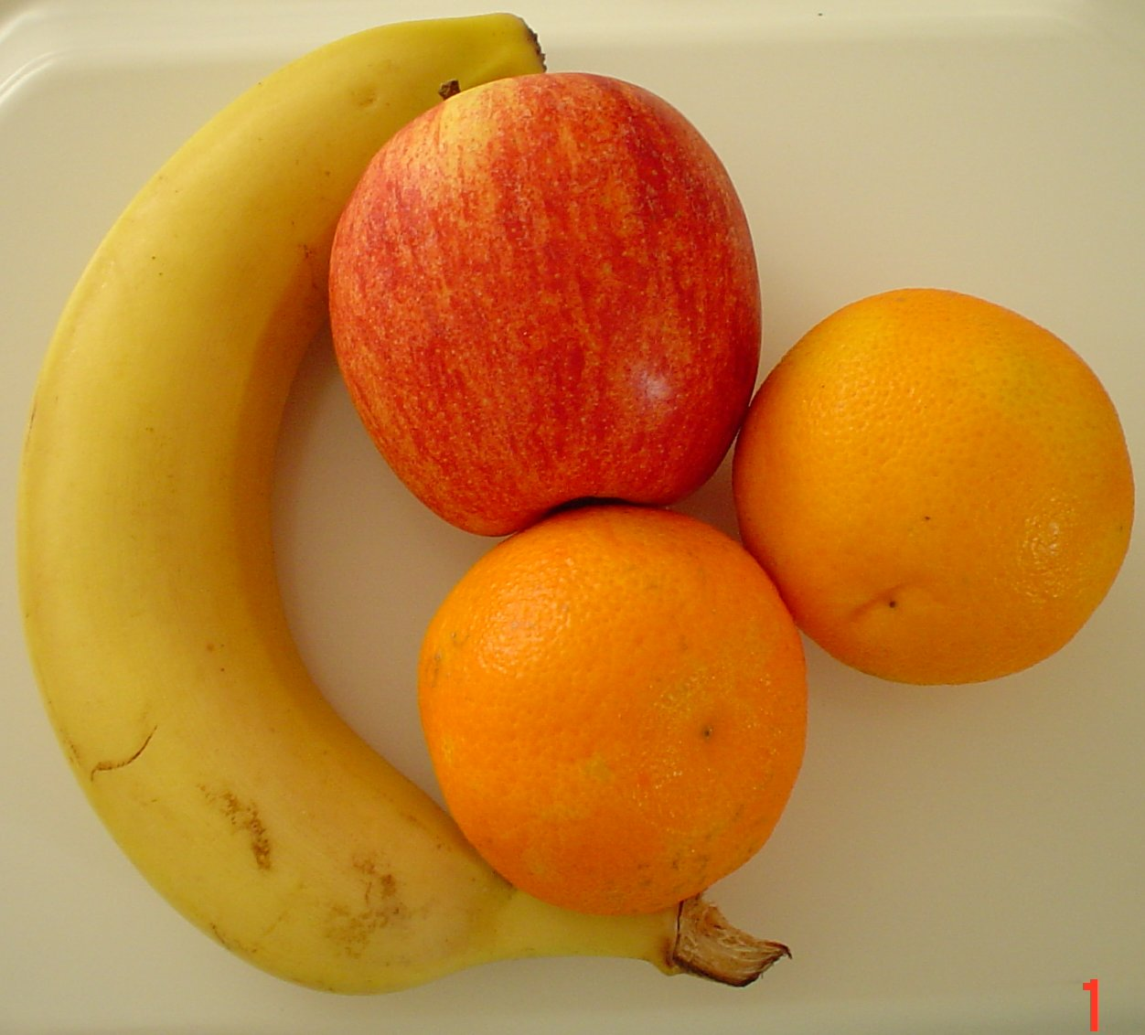
Figure 1: Images with various fruits.
Desired Output:
Adjusting brightness to different levels:
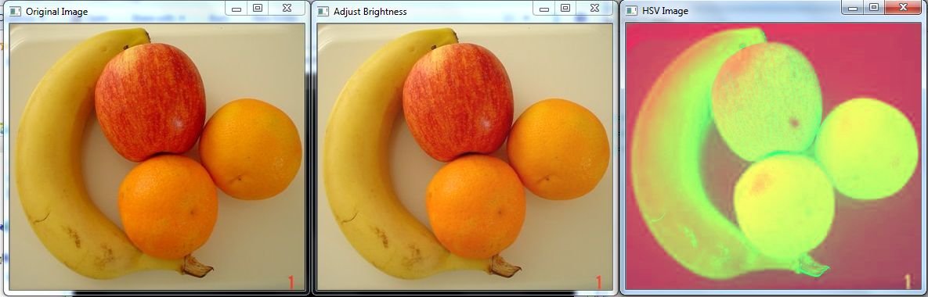
RGB to HSV conversion:

Object detection based on color in RGB domain: (Show the result for original and all brightness adjusted images)
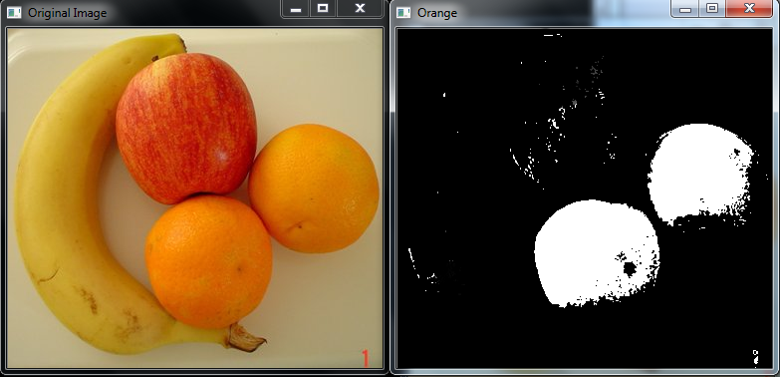
Similarly show results for object detection based on color in HSV domain for original and all brightness adjusted images.
Where to submit the assignment: eLearning.
Late Submissions: Accepted. However, there will be a penalty when you are late.
Rubrics:
Load and Display Images – 10 points.
Adjust brightness to different levels -- 20 points
Convert to HSV Images -- 20 points
Detect Oranges in RGB domain for all images -- 25 points
Detect Oranges in HSV domain for all images -- 25 points
NOTE: Step 1 and 2 cannot use built-in OpenCV functions – operate on each pixel value.

